Creating Your Resume Guide

**Creating Your Resume Guide**

**"Job seekers have just 7.4 seconds to make an impression on recruiters, but can improve their resumes for extra attention."**

**–** [**Ladders, Inc.**](https://www.theladders.com/)**​**

**Key Takeaways:**

1. By the end of this MIlestone, you will be able to develop a draft of your resume.
2. After reviewing the instructions below, develop a draft of your resume, and [submit to a Profile Coach on BCS for feedback.](https://www.bootcampspot.com/login)​
3. For more insight on developing your resume, [click here to view a “Polishing Your Resume & Cover Letter” workshop](https://youtu.be/aAPB7c7xCGc).

Your resume is your chance to impress an employer with your skills and accomplishments. An Employer Competitive resume focuses on **results**, uses **dynamic language**, and is **organized**, visually clean, and mistake-free.

**GETTING STARTED**

1. Review the resume criteria and templates below to develop a draft for review by a Profile Coach.
2. If this is your first time developing a resume, you can use our [‘Step-by-Step Guide’](https://careerservices.gitbook.io/career-resources-data-analytics-library/-LjRMfertuZzhAIzJI8A/er-milestone-create-professional-materials/step-by-step-guide-to-creating-a-resume) for more support.
3. If you’d like additional support with resumes, see the resources we’ve included at the end of this guide.
4. Once you’re done, [submit your draft on the Career Services page in BCS](https://www.bootcampspot.com/login). A Profile Coach will offer unlimited feedback to help you develop an Employer Competitive resume.

Use the following criteria to develop your resume. Your Profile Coach will use the same set of criteria when providing feedback.

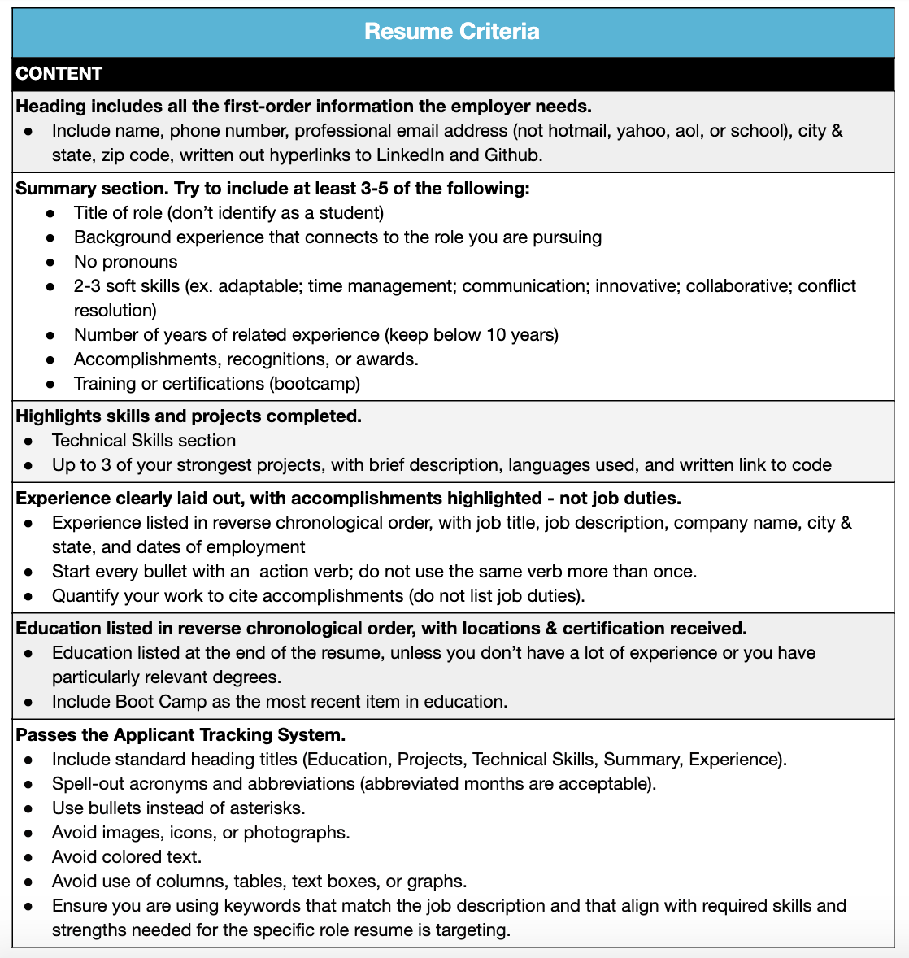

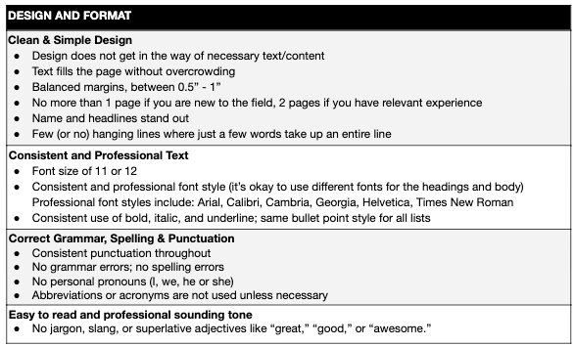

**RESUME TEMPLATES**

Here are templates that you can use to get started on creating your resume. Simply save a copy of the template sheet so you can edit and adapt it. Be sure to replace text in blue with your own, and follow the instructions in brackets.

**​**[**Click here to view resume templates.**](http://bit.ly/2LWC40W)**​**

**ADDITIONAL RESOURCES**

* ​[4 Winning Strategies for Tech Resumes](https://www.blueridgeresumes.com/jobseeker/2017/3/23/4-winning-strategies-for-tech-resumes)​
* ​[6 Ways to Pass the 6-second Resume Test](https://www.youtube.com/watch?v=l_v12n1bZFc)